

# Sharing a GIS Technique for Data Regarding Wrong Way Driving

A Different Approach for Investigating Wrong Way Driving

06/2021

Minnesota Department of Transportation’s Metro District  
Traffic Engineering’s Program Support  
1500 County Road B2 W  
Roseville, MN 55113  
(651) 234-7500  
metroinfocenter.dot@state.mn.us  
<https://www.dot.state.mn.us/metro/trafficeng/contacts.html>

Prepared by Mathias Dall, Research Analyst

## Contents

Sharing a GIS Technique for Data Regarding Wrong Way Driving 1

Contents 3

Difficulty with Wrong Way Crash Type - Too Rare and Too Random 4

Common Approach 5

Proposing a Different Approach with a GIS Technique 6

Wrong way driver 911 dispatch calls 6

Wrong way driver paths 7

Visualizing the approach 8

Outcome of new approach 9

Appendix – Dispersion of Wrong Way Driving Paths 10

## Difficulty with Wrong Way Crash Type - Too Rare and Too Random

There is a lot of uncertainty with wrong way crashes. Aside from what causes wrong way driving and how to prevent it, the largest uncertainty is about where wrong way drivers are entering onto highways. Combining high speeds on divided highways with vehicles coming together head-on results in very serious crashes.

Crash report databases typically have the geographic coordinates for crashes that include other attribute information like date or narratives from police officers. A lot of the time these narratives the entry point of the wrong way driver is unknown, this is especially true with higher severity crashes. Investigations mostly rely on traffic cameras to back track the paths of these wrong way drivers. Details are limited if the drivers are severely injured or common with most wrong way crashes where the wrong way driver is extremely intoxicated.

A common description in all of these is their randomness. The number of the wrong way crashes on divided highways relative to other crash types is small. Once sifting them out of the crash database it can be difficult to make any generalizations from a crash listing. Due to the small sample and layers of uncertainty attitude the product is a shared belief that wrong way crashes are too rare and too random for acknowledgment.

From the engineering area’s perspective for Toward Zero Death initiatives, deciding to invest in countermeasures for wrong way driving cannot proceed if there is severe deficit in data. Transportation professionals cannot estimate a predicted safety improvement if there is no information when comparing costs and benefits. Switching instead to a strategy centered around other areas like enforcement is common to mitigate wrong way driving and crash problems.

The subsequent content will propose a different approach to analyzing wrong way driving by utilizing a GIS technique. Combining 911 state dispatch data with this GIS technique can help increase the overall amount of data related to this problem. Traffic safety professionals can use this approach and identify specific entry points onto divided highways that relate most closely to serious wrong way crashes. Much like when IT security professionals find vulnerabilities in the operating system and release a patch update, traffic safety analysts can rank riskier wrong way entry points for their highway systems and improve intersections by adding countermeasures. Similar to IT security analysts using tracing to detect patterns in their investigations this GIS technique attempts to trace paths of wrong way drivers back to a likely intersection.

## Common Approach

Utilizing hot spot analysis is a useful GIS tool because it provides a lens for reading lots of data points over a geographic area. There are different strategies to aggregate data and analyze it. Creating hot spot maps using a fishnet (Figure 1) or aggregating nearest neighbors (Figure 2) are common types of analysis.

**Figure 2: Wrong way crash map using fishnet**

**Figure 1: Wrong way crash map using fishnet**

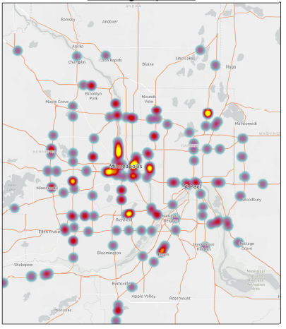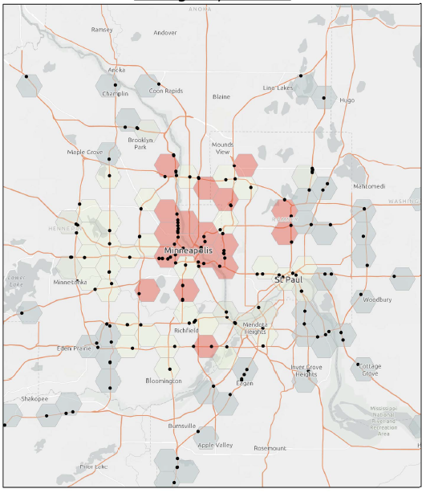

## Proposing a Different Approach with a GIS Technique

There is other data outside of crash databases that serve as indicators of wrong way driving too. Such as citations and 911 dispatch calls.

Along with having readily available citation and 911 dispatch call data points this new approach will require updating a list of entry points. These are where wrong way drivers are known to or possibly have entered divided highways.

The known and possible paths of wrong way drivers from these crashes can be drawn as GIS lines. Utilizing these line paths, dispatch calls and/or citations data can then be summarized using GIS tools. Using paths can give a more precise estimate of wrong way entries at specific locations compared to hot spot analysis. The entry points listings then become a way to rank sites by the total number of dispatch calls and citations associated with it.

**Figure 3: 911 dispatch calls for a wrong way driver**

### Wrong way driver 911 dispatch calls

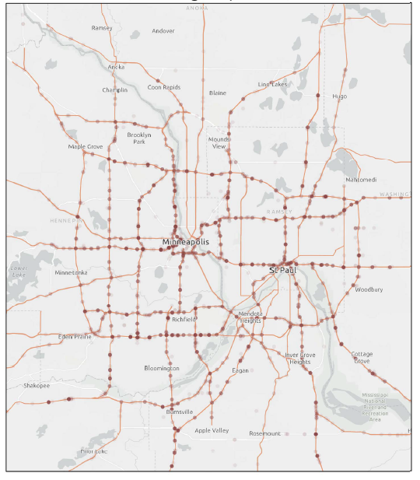Minnesota State Patrol dispatchers record wrong way driving occurrences (Figure 3) at MnDOT’s RTMC - Regional Transportation Management Center. Attributes of this data source include the geographic coordinates and description of these events.

* From 2010 through 2020 there have been 4851 events
* 1665 of these occur in the summer months from June through September (dispatchers will use this code for winter weather related spinouts)
* 1064 of these occur between 9pm through 4am (wrong way driving is more likely to occur throughout the nighttime hours)

### Wrong way driver paths

Drawing driver path lines in GIS for wrong way crashes is a tedious task, therefore planning the GIS workload appropriately is imperative. One critical note when starting out is to consistently draw a path’s starting vertex near the entry point. This is important for the spatial joining path and entry point data.

A handful of the narratives for wrong way crash reports might have the specific entry location described, however, most will likely be uncertain on the entry points. Applying an assumption helps build this GIS approach. The assumption is connecting uncertain crash locations to their closest entry points. The number of closest entry points can unlimited, but assuming more entry points between the closest and next closest location increases the workload. Analyzing path distance data for MnDOT’s Metro District supports the assumption that most wrong way crashes occurred near their closest entry points (Appendix A).

One example entry point in MnDOT’s Metro District, with a history of wrong way crashes, is at the N 2nd Ave and N 4th St intersection in downtown Minneapolis. This exit ramp for Interstate 94 was chosen for a [wrong way detection project](https://www.startribune.com/mndot-testing-system-on-downtown-minneapolis-ramp-to-prevent-wrong-way-drivers/572901071/?utm_content=&utm_medium=email&utm_name=&utm_source=govdelivery&utm_term=). This ramp had three known and three possible entries associated with wrong way crashes: one property damage crash, two serious injury, and three fatal crashes (Figure 4).

Possible paths were made for the three closest entry points regarding each wrong way crash categorized with an unknown entry point was applied with this GIS technique for the Metro District. Overall, there are relatively fewer known paths and entries compared to possible paths and entries (Figure 5).

**Figure 5: Entry points and paths from crash data**

**Figure 4: Entry point example**

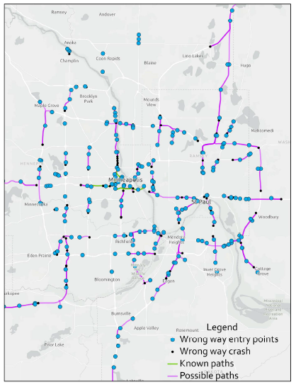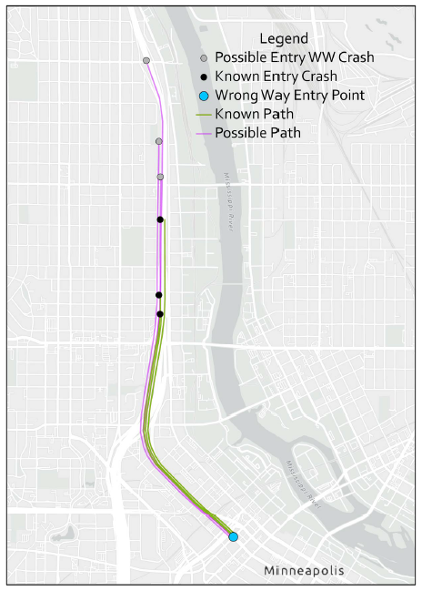

### Visualizing the approach

This example uses the wrong way paths from entry point N 2nd Avenue and N 4th Street intersection (Figure 6). Along these paths, the dispatch calls can be selected using GIS tools (Figure 7).

A crucial step in summarizing data along paths is focusing on one entry path and removing others. A plan will need to be made for which paths to systemically use when selecting data. This custom choice of the longest/shortest, known/possible paths will ultimately determine which entry points are ranked as most likely to have wrong way drivers.

**Figure 7: With selection**

**Figure 6: Before selection**

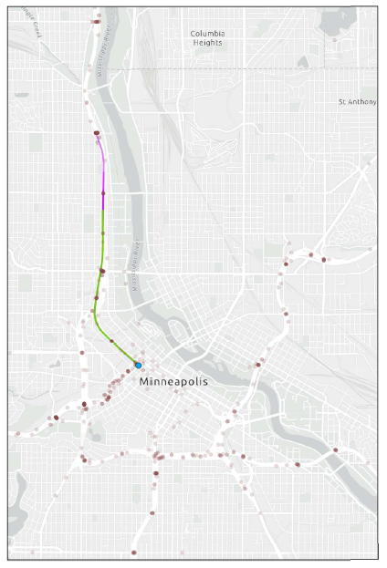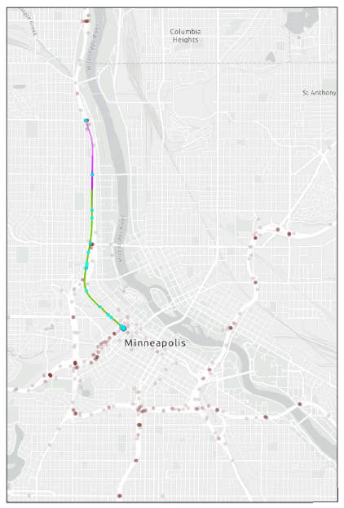

## Outcome of new approach

This proposed GIS approach allows for a systemic comparison of entry points. A risk score can include data of wrong way crashes, 911 dispatch calls, and citations. Below are maps utilizing proportional symbology based just on the total number of specific 911 dispatch calls related to wrong way driving (Figure 8). For MnDOT’s Metro District, entry points related to freeways near downtown Minneapolis have far more dispatch calls (Figure 9).

This approach also provides more information for investigating the wrong way driving problem. With more information to use, hopefully transportation safety professionals can become certain as to which areas are more likely to have wrong way driving. Optimally choosing the areas most likely to have wrong way driving and considering needed countermeasures should help reduce the number of serious crashes.

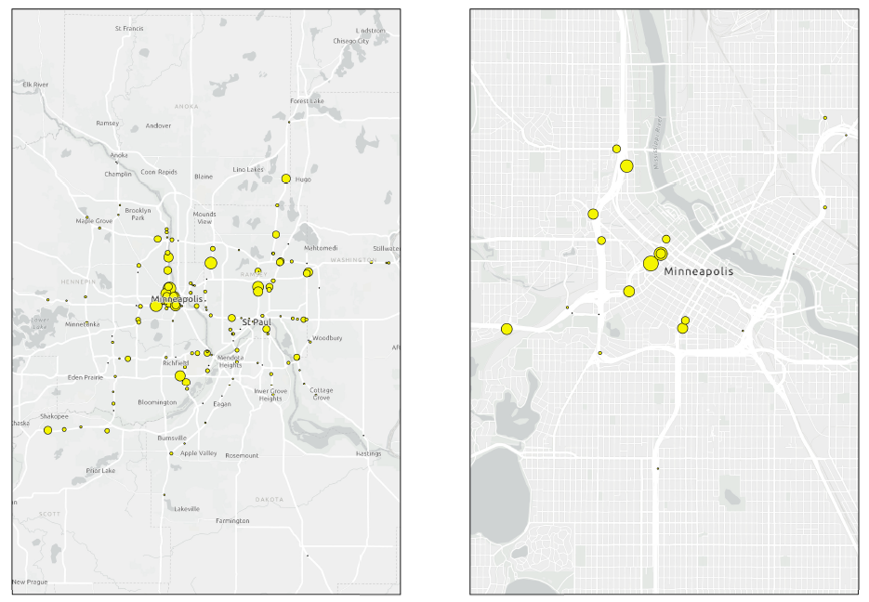

**Figure 9: Downtown Minneapolis entry points**

**Figure 8: Metro District proportional map**

## Appendix – Dispersion of Wrong Way Driving Paths

