Investigating Wrong Way Crash Data Systemwide
Crashes on Divided Highways in the Metro District (2010 – 2019)
12/2021

Minnesota Department of Transportation’s Metro District
Traffic Engineering’s Program Support
1500 County Road B2 W
Roseville, MN 55113
(651) 234-7500
metroinfocenter.dot@state.mn.us
https://www.dot.state.mn.us/metro/trafficeng/contacts.html
Prepared by Mathias Dall, Research Analyst

Contents
Investigating Wrong Way Crash Data Systemwide 1
Contents 3
Introduction 4
Intoxicated Driving is a Public Health Concern 4
Extracting wrong way crash data 5
Querying and compiling a list of wrong way crashes 5
Recommended custom attributes 6
Wrong way crash summary 6
Rare crash type 6
Impaired drivers are typically wrong way drivers 7
Crashes typically occurring in urban areas, late nights, on weekends 8
Wrong way driving paths 11
Tracing paths for wrong way crashes 11
Distance data from traced paths 13
Score and rank wrong way entry sites 15
Ranking wrong way entry sites 15
Next steps 17
Judging the wrong way driving problem at sites 17
Wrong way site at N 2nd Ave & N 4th St downtown Minneapolis 20
Wrong way crash history 20
Detection system 22
Wrong way driving literature and takeaways 24
Majority of wrong way drivers had high BACs 24
Considering factors to prevent entries 24
Choosing a good countermeasure 25
Conclusion 26
Appendix A 27

Introduction
This report will provide information about wrong way driving and crashes on divided highways in Minnesota’s Metro District, share insights, and information gathering recommendations for other transportation agencies. The NCHRP Research Report 881 Traffic Control Devices and Measures for Deterring Wrong-Way Movements is a recommended first read. It is a comprehensive report on wrong way crashes on divided highways by synthesizing studies across states on crash data and the effectiveness of countermeasures.
In the NCHRP report it references the difficulty with identifying the origin of wrong-way maneuvers onto divided highways. It also calls out the need for such reports that study wrong way crashes onto divided highways and more robust datasets to investigate characteristics of crashes. Such findings will aid traffic safety professionals deploying countermeasures to prevent wrong way entries onto divided highways. In this report Investigating Wrong Way Crash Data Systemwide lessons shared are recommendations to designing a query of crash data and utilizing a GIS technique to help identify wrong way entry sites.
Given the high speeds on highways and the potential for more severe head-on crashes due to a driver entering the wrong way, this crash type is a contributor to highway deaths across all states. In consideration to Toward Zero Death Initiatives, understand that the public health concern of impaired-drunk driving is important for this specific crash type. Wrong way driving is typically a drunk driving problem.
This report shares insights from utilizing other data related to wrong way driving such as citations and state dispatch calls. Wrong way driving data is also analyzed with alcohol-related data like Place of Last Drink datasets and on sales liquor license locations.

Intoxicated Driving is a Public Health Concern
Nearly 30% of all traffic crash fatalities (37,133) involve alcohol-impaired drivers according to a study in 2017 by The National Highway Traffic Safety Administration. The NTSA also found that 84% of these drivers had BACs 0.08 mg/dL or greater. The annual economic costs were reported to be $44 billion in 2010, more than $55 billion when adjusted for 2021. These drivers are not risking their own safety but the lives of everyone on the road. The Center for Disease Control and Prevention reported in 2012 there were 121 million alcohol-impaired driving occurrences. In Minnesota, a study looked at DUI arrests and data relating a driver’s place of last drink and found them to be driving many miles before their arrest (estimates on average close to 4.6 miles). The average BAC level for their dataset was 0.147 mg/dL. Most of these citations occurred between 10pm and 2am. The same CDC report estimated that an arrest occurs every 1 in 1,700 alcohol-impaired trips that do not result in a crash.
The AAA Foundation for Traffic Safety reports that fatal wrong way crashes on divided highways is getting worse annually. Between 2015-2018 they reported 2,008 deaths from wrong way driving crashes. Alcohol-impairment, older age, and driving without a passenger as three popular crash attributes for wrong way driving. They found 60% of these wrong way drivers had BACs 0.08 mg/dL or greater and alcohol impairment is by far the most significant factor. AAA recommends ignition interlock devices for offenders, high-visibility enforcement operations, and consider infrastructure countermeasures such as more visible traffic signs and signals.

Extracting wrong way crash data
This report is concerned with crashes that occurred on divided highways among the trunk highway system for the Metro District. One hope from investigating these crashes was there could be more information on which intersections wrong way drivers are entering the highway system.

Querying and compiling a list of wrong way crashes
Officers will file reports for wrong way crashes with different attributes. Since it is a rare crash type, identifying it as a wrong way crash in a data field can be missed. Developing a search based on crash narratives should help increase the total number of wrong way crashes that would be missed if a query relied on just one data field. Some recommendations are:
- Query narratives for the phrase “wrong way”
  - Remove crashes that include the phrase “facing wrong way” or “facing the wrong way”
  - Officers will use these phrases if a driver wipes out due to events like snow or ice on roadways
- Remove crashes where drivers intentionally go the wrong way to avoid police, however there will be crashes related to police interventions like pit maneuvers because wrong way drivers typically are impaired. These should be kept.
- Query narratives for the phrase “traveling in the wrong direction”
- Query narratives for various forms of directional descriptions:
  - Northbound in the southbound
  - NB in the SB / NB in SB
  - North in the southbound

Recommended custom attributes
Crash data systems are well designed for automation and summarizing. Given the complexity of a wrong way crash however it adds a lot of manual work to get a valuable dataset. It is recommended that a listing includes identifying which driver in the crash record is the wrong way driver. Also, another attribute that indicates if the crash’s location is on the highway’s mainline or an off ramp. Finally, an attribute that has a short description such as:
- Impaired driver (drunk driver)
- Elderly driver (those older than a certain old age)
- Medical issue
- Sleepy driver
- Distracted driving
- No clear reason (a wrong way driver caused the crash but not at the scene “hit-and-run”)
Something to keep in mind is that a wrong way driver might have spun themselves around instead of entering somewhere incorrectly. This is true of drunk drivers and/or environments that snow with blurry visibility like Minnesota. Balance this idea with the introductory message from studying POLD that drunk drivers do drive long distances, there is still value attempting to find the most problematic intersections for drivers to enter the wrong way.

Wrong way crash summary
Crashes are from 2010 through 2019. These occurred in MnDOT’s Metro District which includes the counties around the Twin Cities area: Anoka, Carver, Chisago, Dakota, Hennepin, Ramsey, Scott, and Washington.

Rare crash type
Per year about 18 wrong way crashes have occurred on divided highways. Some insights from looking at crashes by severity:
- Three high severity crashes (fatal or serious injury) occur per year
- Most of these high severity crashes occur on a highway’s mainline 28/30
- Two out of three wrong way crashes have occurred on the mainline

Severity tables
The left table summarizes all wrong way crashes by injury severity. The right table divides these crashes into separate groups: those that occurred on a highway’s mainline compared to those occurred on ramps.

Impaired drivers are typically wrong way drivers
Impaired / drunk drivers should be the focus of the wrong way driving problem. They contribute more to wrong way crashes and more high severity crashes compared to older / elderly drivers.
- Impaired / drunk drivers accounted for nearly half of all wrong way crashes (48%)
- Most high severity wrong way crashes were due to an impaired driver (73%)
- Older / elderly drivers was the next most popular reason for all wrong way crashes (15%)
- 1 out of the 30 high severity crashes was due to an older / elderly driver
- More than a quarter of crashes have no clear reason why the driver was driving the wrong way because they were not at the scene of the crash most of the time since they hit-and-ran or caused correct way drivers to crash.
- The next group with high severity crashes is those where the wrong way driver had no clear reason driving the wrong way likely because the driver was killed at the scene.

Short reason descriptions
The top chart divides all wrong way crashes by short reason descriptions. The bottom chart divides high severity wrong way crashes by short reason descriptions.

Crashes typically occurring in urban areas, late nights, on weekends
Impaired / drunk impaired / drunk drivers that contribute the most to wrong way crashes and particularly higher severity ones too.
- Urban environments Minneapolis (37) and Saint Paul (15) had the most wrong way crashes.
- Hennepin county (92) had more than half the total amount and more than double the next county, Ramsey (35).
- Most crashes typically occur 7pm until 4am, peaking around 2am.
- Wrong way crashes with impaired drivers occur most on Friday, Saturday, and Sunday.
- Impaired /drunk drivers make up most of the atypical driving hours late night / early morning.
- Elderly / older drivers are more common during normal driving hours.

Crashes by time
The top chart divides all wrong way crashes by the hour of day. The bottom chart shows total wrong way crashes by day of the week with an impaired driver and in particular comparing drivers aged 20-40.

Wrong way driving paths
Looking at maps where wrong way crashes occur systemwide doesn’t provide a lot of actionable information. By drawing paths of a wrong way driver, intersections can be summarized systemwide by possible and known wrong way entries. Tracing these paths is a major time investment. However, these paths can be used to make other data actionable like dispatch calls (see report “Sharing a GIS Technique for Tracing Data Regarding Wrong Way Driving”).

Tracing paths for wrong way crashes
Officers might add into the narratives where a wrong way driver was known to have entered. Most of the time however, it is uncertain how a driver started going the wrong way. Summarizing intersections systemwide for known or possible wrong way entries helps prioritize safety concerns of wrong way drivers. Scoring intersections based on crash data, citations, dispatch calls, and other sources like place of last drink datasets can help rank intersections as more likely to have wrong way drivers enter. This starting step can then help the next step of traffic safety engineers investigating these higher-ranking intersections like with video detection systems.

Example mapping paths of wrong way drivers
This map shows paths of wrong way drivers. Both possible and known paths are included. Also visible are the counties and trunk highways in the Metro District.

Distance data from traced paths
Tracing paths provide estimates of the distances travelled by wrong way drivers from crash data. Known paths of drivers can be read from narratives of the crash reports where officers indicate the entry point. Possible paths can be traced from the closest entry points on the highway system. Note that nationwide there are stories of wrong way drivers travelling absurd distances before a crash or intervention. For example, near Phoenix, Arizona there was a wrong way driver that traveled nearly 40 miles on an interstate. Choosing the number of next possible entry points while tracing paths should consider factors like urban/rural and traffic volumes (especially during atypical driving hours). As explained in “Sharing a GIS Technique for Tracing Data Regarding Wrong Way Driving”, increasing the number of next possible entry points increases the GIS workload significantly.

Distance data of traced paths – box whisker plots
These box whisker plots visualize the distance values of known and/or possible paths of impaired or older wrong way drivers. Some insights are:
- Known paths of older drivers had the shortest distances likely due to this type of wrong way driving event occurring during normal driving hours
- Known paths contain shorter distances because most of these types of crashes occur on off ramps
- The upper values of possible distances for impaired drivers are much longer than those for older drivers because one occurs more often during atypical driving hours compared to other.
- A majority of these traced possible paths are going to be around two miles or shorter while a quarter of them are going to be longer.

Score and rank wrong way entry sites
A quick conclusion is generalizing that wrong way crashes are a symptom of drunk driving and too rare or random for systemwide considerations. However, this report helps gain information on which entry sites throughout the Metro District could potentially have a wrong way driving problem. Scoring them helps prioritize which sites traffic safety engineers should prioritize in their investigations of wrong way driving,

Ranking wrong way entry sites
A rank score can be given to wrong way entry sites systemwide. Since these sites can be summarized with wrong way data such as: known and/or possible wrong way crashes, citations, and state dispatch calls (see report “Sharing a GIS Technique for Tracing Data Regarding Wrong Way Driving”).
Creating a custom score requires a model that weights data from these sources appropriately. Regarding rank scores in this report for the Metro District, more weight was given to crashes with known entries and their paths. State dispatch call data during summer months was given more weight since the codes for wrong way events in winter months could be used for drivers who spun out in the snow. Also, more weight was given to the hours 7pm through 4am based on the analyzing crashes and state dispatch calls broken out by day and hour (see Appendix A).

Table and map regarding rank scores of wrong way entry sites
The following is a visual of a listing of top-ranking wrong way entry sites. Two sites have rank scores greater than the rest of the list. These are in downtown Minneapolis in the North Loop and Warehouse District.
Below the table is a map of the proportional rank score for each wrong way entry site systemwide. The larger the dot means the greater the rank score. The map shows downtown Minneapolis has a lot of entry points that potentially have a wrong way driving problem.

Next steps
This report sets up the next steps in helping reduce wrong way crashes. It should be used as a map to guide which sites should be investigated when appropriate. Verifying if there is an actual problem and choosing good countermeasures are important next steps.

Judging the wrong way driving problem at sites
A list of sites with a likely wrong way driving problem can be investigated further. A next to step is to verify wrong way entries typically with video detection systems. Traffic engineers can judge the safety problem based on this video evidence. Other areas of Toward Zero Death initiatives like enforcement can benefit from sharing information from this wrong way driving report and site investigations. Combining wrong way driving data with data like Place of Last Drink can increase the importance of enforcement in targeted areas especially by day and time.

Heat maps of locations with on sales liquor licenses and place of last drink (POLD)
The first heat map shows where there are a lot of establishments with on sales liquor licenses. The red shows Minneapolis has a lot in a close area followed by St. Paul. This heat map includes the rank scores of wrong way entry sites. With them included it shows the sites with highest rank scores are in the area of Minneapolis with many on sales liquor licenses.
The second heat map shows where a lot of officers have reported the place of the last drink for those who chose to drink and drive illegally. These state databases are being created nationwide to help decrease the consequences of drunk driving. The wrong way driving problem is a case for increasing the value of such databases. Although from 2014-2018 Hennepin county was primarily trained to enter reports to POLD, we can see that, like the first heat map, the same area of Minneapolis is near the wrong way entry sites with the highest rank scores. Another observation from this heat map is that one area in Excelsior, MN also had a lot of place of last drink reports. Excelsior’s environment is quite different from Minneapolis’s urban downtown environment. However, they do offer tourist attractions.
To note wrong way entry sites near Excelsior did not have high rank scores. Also, it is interesting that downtown St. Paul doesn’t have high ranking wrong way entry sites as well despite a lot of establishments with on sales liquor licenses. These observations just reinforce the complexity of understanding the wrong way driving problem systemwide. Therefore, sharing the approaches and lessons learned matters for transportation agencies nationwide.

Wrong way site at N 2nd Ave & N 4th St downtown Minneapolis
This site is known to have a wrong way driving problem. It was chosen to have a pilot project to help prevent wrong way entries. Video detection system confirmed wrong way entries. The results of this wrong way detection system should be shared to help other transportation agencies choose good countermeasures.

Wrong way crash history
There have been fatal and serious injury wrong way crashes since 2010. Four wrong way crashes occurred where it is known the driver entered this site the wrong way. Each of these are fatal and serious injury crashes. There are two possible crashes where the driver may have entered this site. Crashes occurred between 9pm and 2am.

Wrong way crash map at N 2nd Ave & N 4th St
The map below shows all crashes where a driver possibly or known to have entered this site the wrong way. It shows the paths and the crash locations.

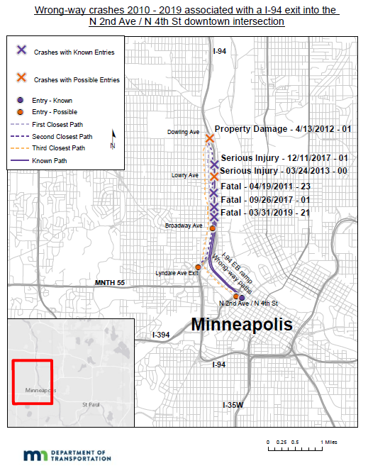

Detection system
The detection system for wrong way drivers flashes LEDs on the wrong way signs. By flashing the signs, it should serve as an additional visual cue for these drivers. The system’s annual contract started in October 2020 and the results will be shared.

Site Characteristics
A lot is going on in this map of the intersection. There are other freeway exit and entrance ramps with parallel city streets. Sport entertainment venues are close to this intersection as well as other tall buildings downtown. Parking garages are adjacent to these ramps. As a reminder, this area offers many nightlife attractions.
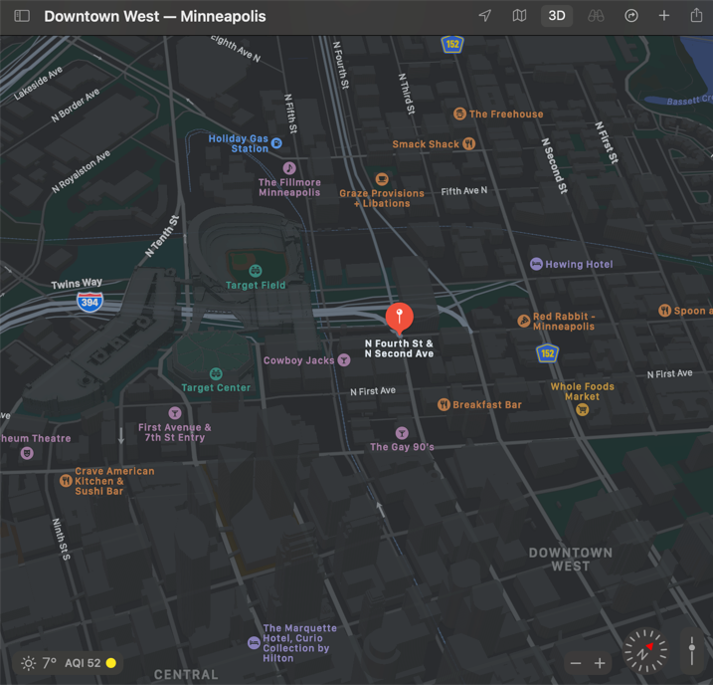

Verifying examples
Below are two snapshots of wrong way entries at N 2nd Ave & N 4th St. One occurs mid-day at noon and the other occurs at midnight. Verifying wrong way driving with video or a photo detection system at a site is a recommended next step after systematically ranking sites based on wrong way driving data.
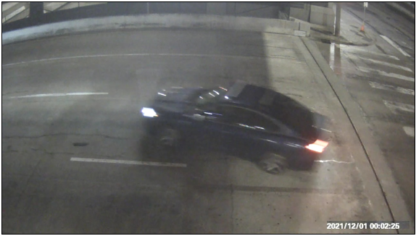
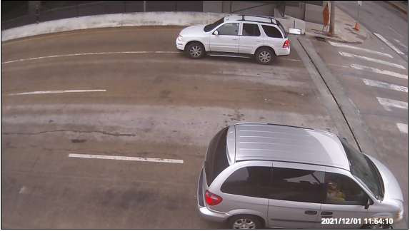

Additional enhancements to deter wrong way entries
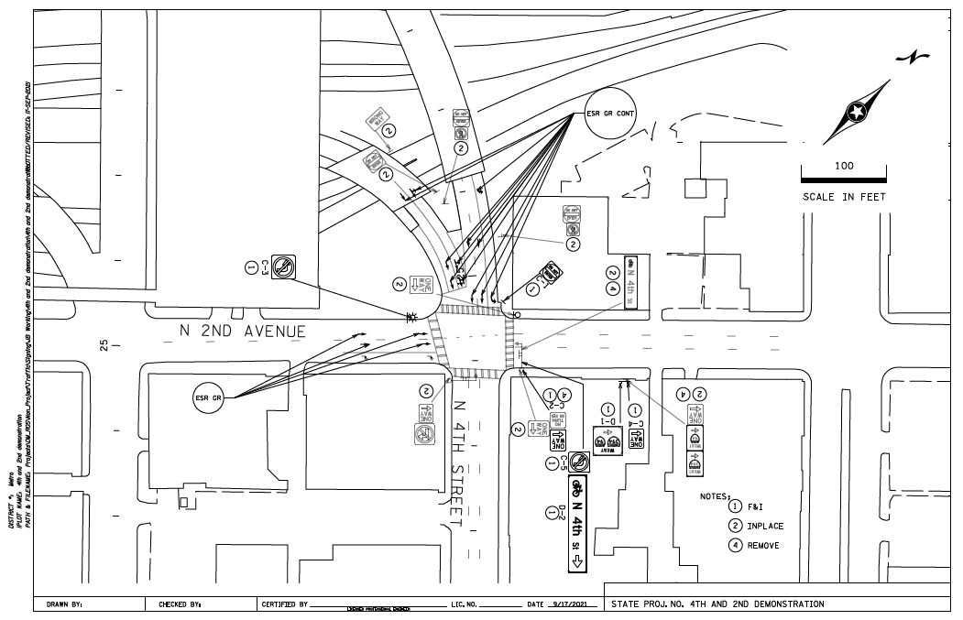
MnDOT added more signs and pavement markings to increase the number of visual cues. Below is a site plan showing them.

Wrong way driving literature and takeaways

Majority of wrong way drivers had high BACs
Consistent across literature from state and national transportation agencies is that most wrong way drivers are impaired drunk drivers. The NTSB in a FARS analysis of 2004-2009 data found nearly 70% of crashes where the wrong way driver was alcohol impaired. Close to 60% had twice the legal limit. For example, at the state level for Texas they found 90% of wrong way drivers equal to or greater than the legal limit. 50% were twice the legal limit and 10% were three times.
The NCHRP research report 881 also notes that many studies find wrong way drivers involved in crashes on freeways tend to be young men who are impaired. They have also found in many studies that these crashes occur typically at night and weekends in urban areas. The Metro District’s crash data insights earlier in this report confirm much of these notes on other studies across the nation.

Considering factors to prevent entries
Factors other than interchange design significantly influence wrong way entries too. Prescence of frontage roads, tourist attractions, and recreation are factors to consider near wrong way entry sites.
States have conducted human factor studies like driver simulations and closed course tests to learn more about wrong way drivers. In simulations, Florida found that the more visual cues the less likely wrong way entries and crashes will occur. They also found that the faster a driver enters an off ramp the wrong way the less likely they see and read a visual cue like a sign.
In closed course experiments, Texas found that alcohol impaired drivers will stare at the pavement in front of them rather than reading and scanning the roadway. They also found that drivers with high BACs are slower at reading the text and misidentify colors on signs.
The most popular maneuver entering a divided highway is turning left into the nearest roadway; accounting for 90% of crashes in a safety analysis.

Choosing a good countermeasure
The NCHRP in their safety analysis of wrong way crash attributes found that increasing the number of one way signs, having the required divided highway sign, and placing Do Not Enter and Wrong Way signs on the inside turn of a wrong way movement likely doesn’t get a wrong way driver to turn around. It does seem possible that placing Do Not Enter and Wrong Way signs on the outside of a wrong way movement and wrong way arrow markings on the through lanes as getting a driver to correct themselves.
Focusing on additional countermeasures for wrong way entries onto freeways there are three more: flashing LEDs on wrong way signs, red RFBs on wrong way signs, and bidirectional pavement markings. The NCHRP Research Report 881 covered flashing LEDs results on corridors in San Antonio and South Florida. MnDOT will be sharing the results of its detection system with flashing LEDs for its one year pilot from 2020 through 2021. NCHRP also covered red RFBs for a corridor in Central Florida. Finally, Caltrans has a pilot program currently running in San Diego using bidirectional pavement markings on 30 freeway off ramps. These pavement markings show white for correct way drivers and red for wrong way drivers.

Conclusion
Advanced GIS tools and crash data systems enable traffic safety analysts to better discover new patterns. This report explained how to systematically rank and score a list of wrong way entry sites for divided highways. It utilized a GIS technique of summarizing state dispatch call data along traced paths of wrong way drivers. A quick generalization reacting to wrong way crashes is that they are too random and too rare to systematically approach. Instead by using the lessons learned and information shared from this report, transportation and enforcement agencies can gain more information about wrong way driving on their highway systems. Generally, it is known that wrong way driving is related closely to the impaired-drunk driving problem.
An important note from the National Academies’ Getting to Zero Alcohol-Impaired Driving Fatalities A Comprehensive Approach to a Persistent Problem is the existence of a strong relationship between binge drinking and alcohol-impaired driving. Their recommendation is to design policies to reduce binge drinking by implementing a set of effective interventions and population-based strategies. One example of a policy is an excise tax. There is evidence that higher alcohol taxes reduce alcohol related motor fatalities. However, an excise tax’s effectiveness can erode due to inflation and therefore should be indexed. These taxes can be used to support activities like sobriety checkpoints and alcohol treatment programs. Funding traffic safety assets like the countermeasures above could be financed with such excise taxes since this is one more problem in the logistics of systematically reducing wrong way driving.
Another possible source of funding for activities to reduce wrong way driving Federal Section 164 program. This program sanctions a state for not meeting criteria for intoxicated driving laws and directs federal funds away from highway programs to safety programs administered by MnDOT and DPS. Utilizing the GIS technique in the report “Sharing a GIS Technique for Tracing Data Regarding Wrong Way Driving” traffic safety planners can identify which intersections have a history of fatal and serious injury wrong way crashes for a reactive candidate application of funding. Planners can also identify intersections with risk factors such as state dispatch calls for wrong way drivers, proximity to on sales liquor license locations, place of last drink locations, citations, and other intersection site characteristics to apply a risk-based application of funding.
Efforts to reduce wrong way driving align with traffic safety initiatives like Toward Zero Deaths. The data-driven insights shared should help traffic safety planners organize the histories of wrong way crashes in their districts and change mindsets that these crashes are too random and too rare to systemically prevent from occurring on divided highway systems.

Appendix A
State patrol dispatch calls for a wrong way driver 2010-2019 by day and times of day. 2am is the most popular time for calls.
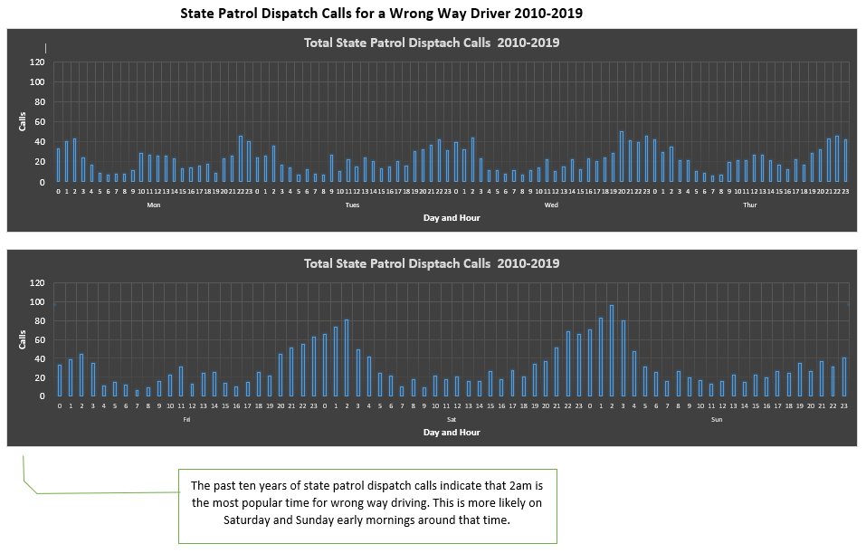

Finley, Melisa D., et al. “Traffic Control Devices and Measures for Deterring Wrong-Way Movements.” 2018, p. 3., https://doi.org/10.17226/25231.
Michaela A. West, MD, PhD1,2; Amber Smith, MPH1; Tara Helm, MPH1; et al “Use of a Statewide Public Health Tool to Estimate Miles Driven by Intoxicated Drivers.” JAMA Surgery, vol. 154, no. 9, 2019, p. 875., https://doi.org/10.1001/jamasurg.2019.1720.
Andrew Gross Manager, et al. “Heading the Wrong Way with ‘Wrong-Way’ Driving.” AAA Newsroom, 23 Mar. 2021, https://newsroom.aaa.com/2021/03/heading-the-wrong-way-with-wrong-way-driving/.
Ktar.com. “Wrong-Way Driver near Phoenix Goes 37 Miles on Interstate 17.” KTAR.com, 9 Sept. 2019, https://ktar.com/story/2733773/wrong-way-driver-near-phoenix-goes-37-miles-on-interstate-17/.
Harlow, Tim. “MnDOT Testing System on Downtown Minneapolis Freeway Ramp to Prevent Wrong-Way Drivers.” Star Tribune, Star Tribune, 2 Nov. 2020, https://www.startribune.com/mndot-testing-system-on-downtown-minneapolis-ramp-to-prevent-wrong-way-drivers/572901071/
, 9 Wrong Way Driving Analysis and Recommendations - Oregon.gov. p. 4., p.15., https://www.oregon.gov/ODOT/Engineering/Docs_TrafficEng/Wrong-Way-Driver-Report.pdf.
,11 Finley, Melisa, and Steven Venglar. “ASSESSMENT OF THE EFFECTIVENESS OF WRONG WAY DRIVING COUNTERMEASURES AND MITIGATION METHODS.” Dec. 2014. .31.,p.47., https://static.tti.tamu.edu/tti.tamu.edu/documents/0-6769-1.pdf
,12 Finley, Melisa D., et al. “Traffic Control Devices and Measures for Deterring Wrong-Way Movements.” 2018, p. 3., p.40., https://doi.org/10.17226/25231.
Lin, Pei-Sung, et al. “Assessment of Countermeasure Effectiveness and Informativeness in Mitigating Wrong-Way Entries onto Limited-Access Facilities.” Accident Analysis & Prevention, vol. 116, 2018, pp. 79–93., https://doi.org/10.1016/j.aap.2017.11.027.
,14 Finley, Melisa D., et al. “Traffic Control Devices and Measures for Deterring Wrong-Way Movements.” 2018, p. 24., p.40-41., https://doi.org/10.17226/25231.
Lane Alert 2x Bidirectional Pavement Markings Pilot Projects. California Department of Transportation, https://pppcatalog.com/wp-content/uploads/2021/02/Lane-Alert-2X-Bi-Directional-Pavement-Markings.pdf.
“Getting to Zero Alcohol-Impaired Driving Fatalities.” 2018,p.S-9-S-11., https://doi.org/10.17226/24951.

